**Experiment-111**

***Ansible Installation***

1. Create 2 AWS EC2 Instance with same key-pair.

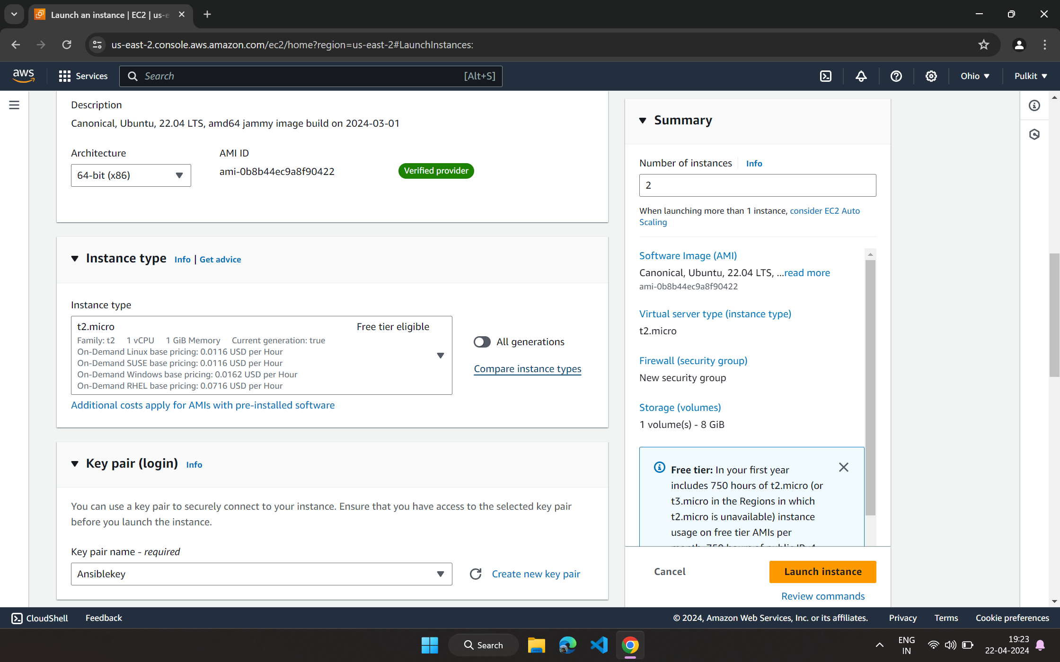

1. Install Ansible in one of the Insatance.

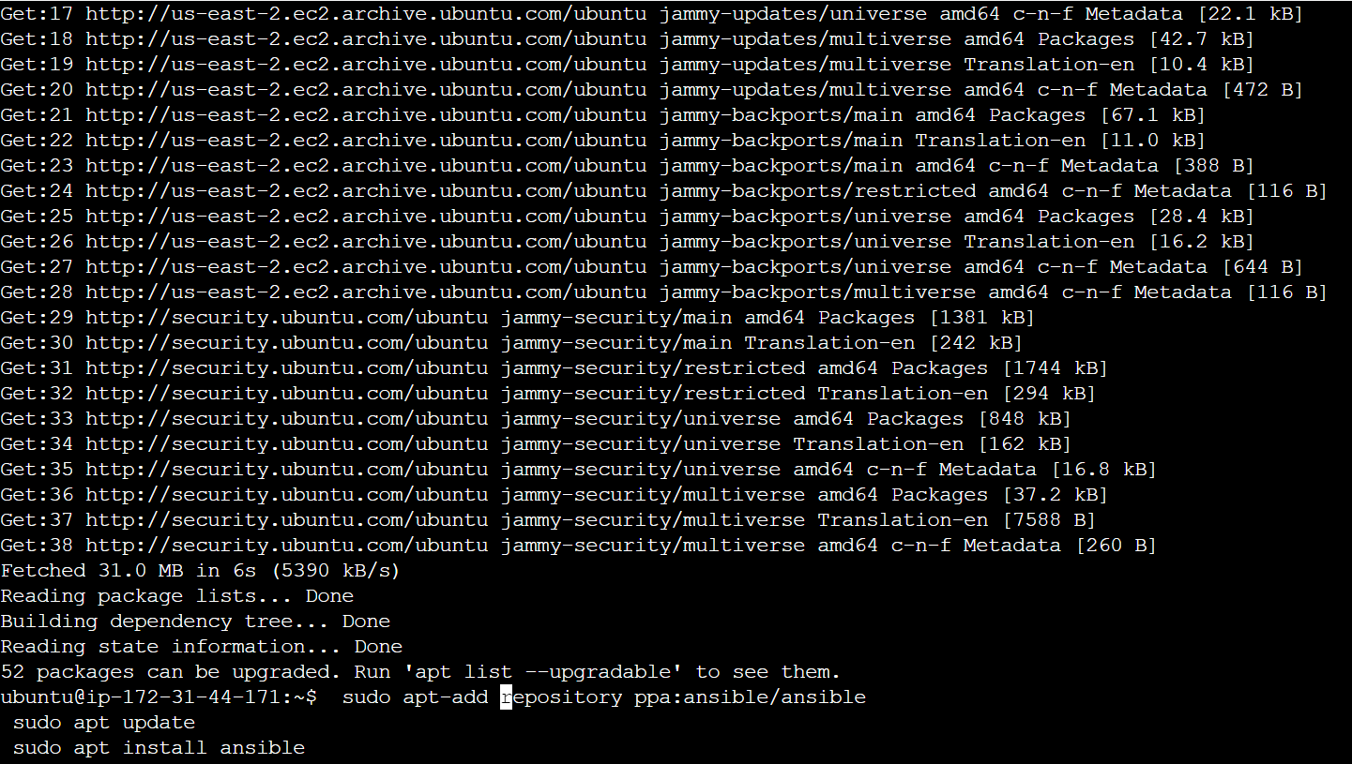

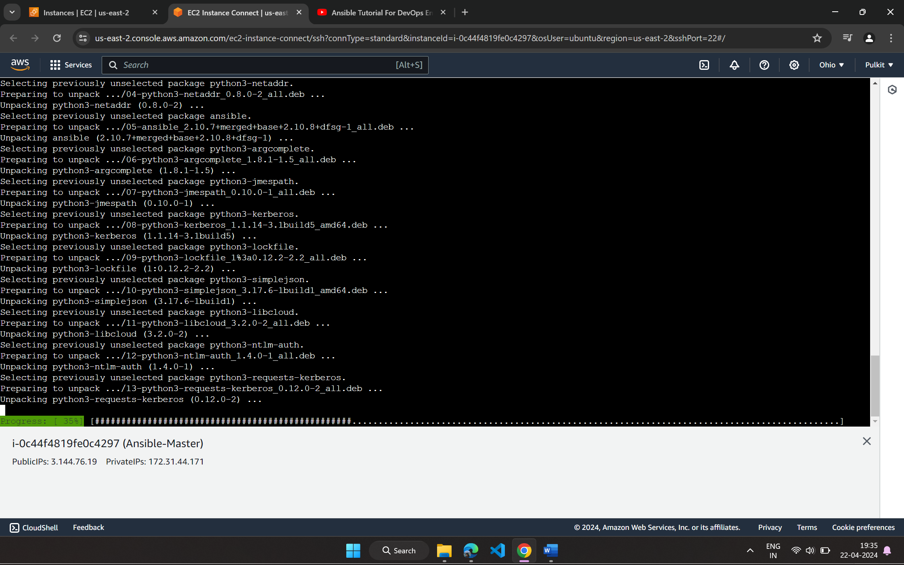

1. Verify installation by checking version.

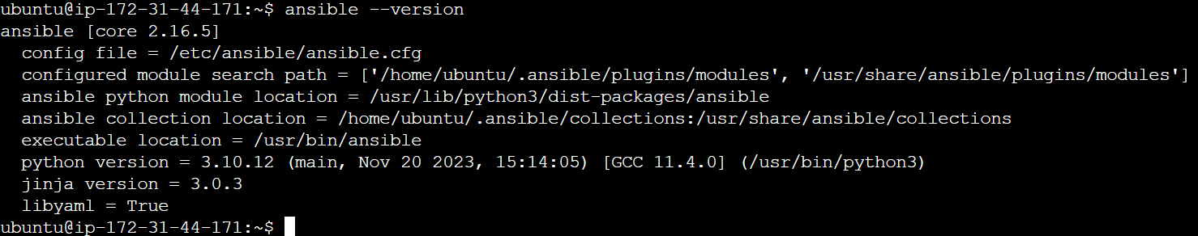

1. Make a directory and using scp copy key-pair PEM file.

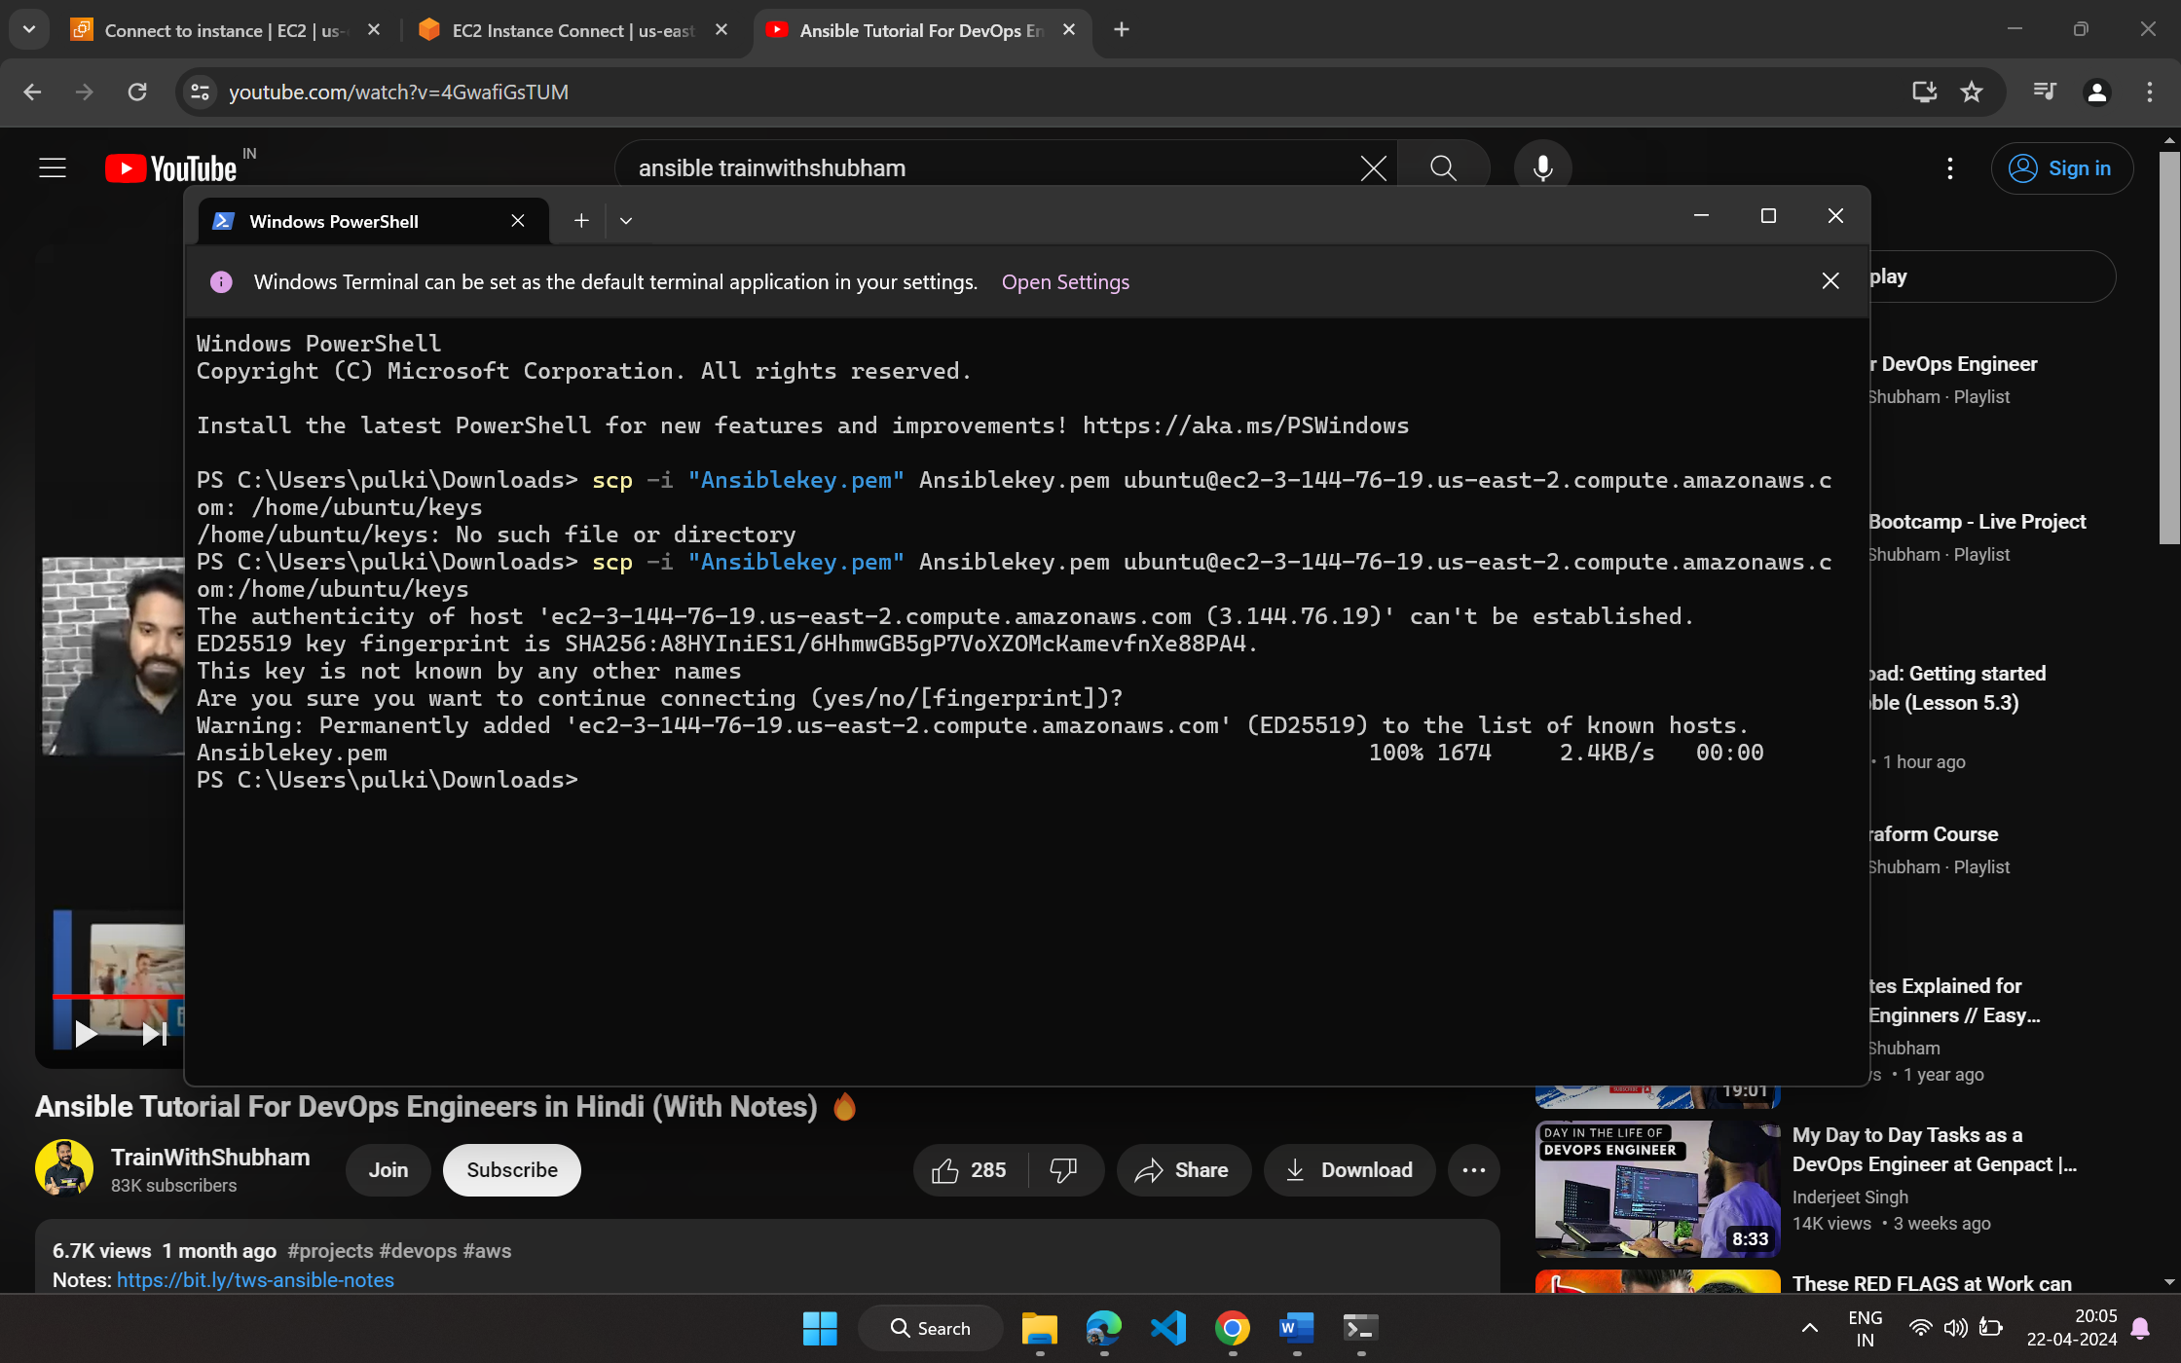

1. Edit **ansible** **host** file and add the public IP of another server.

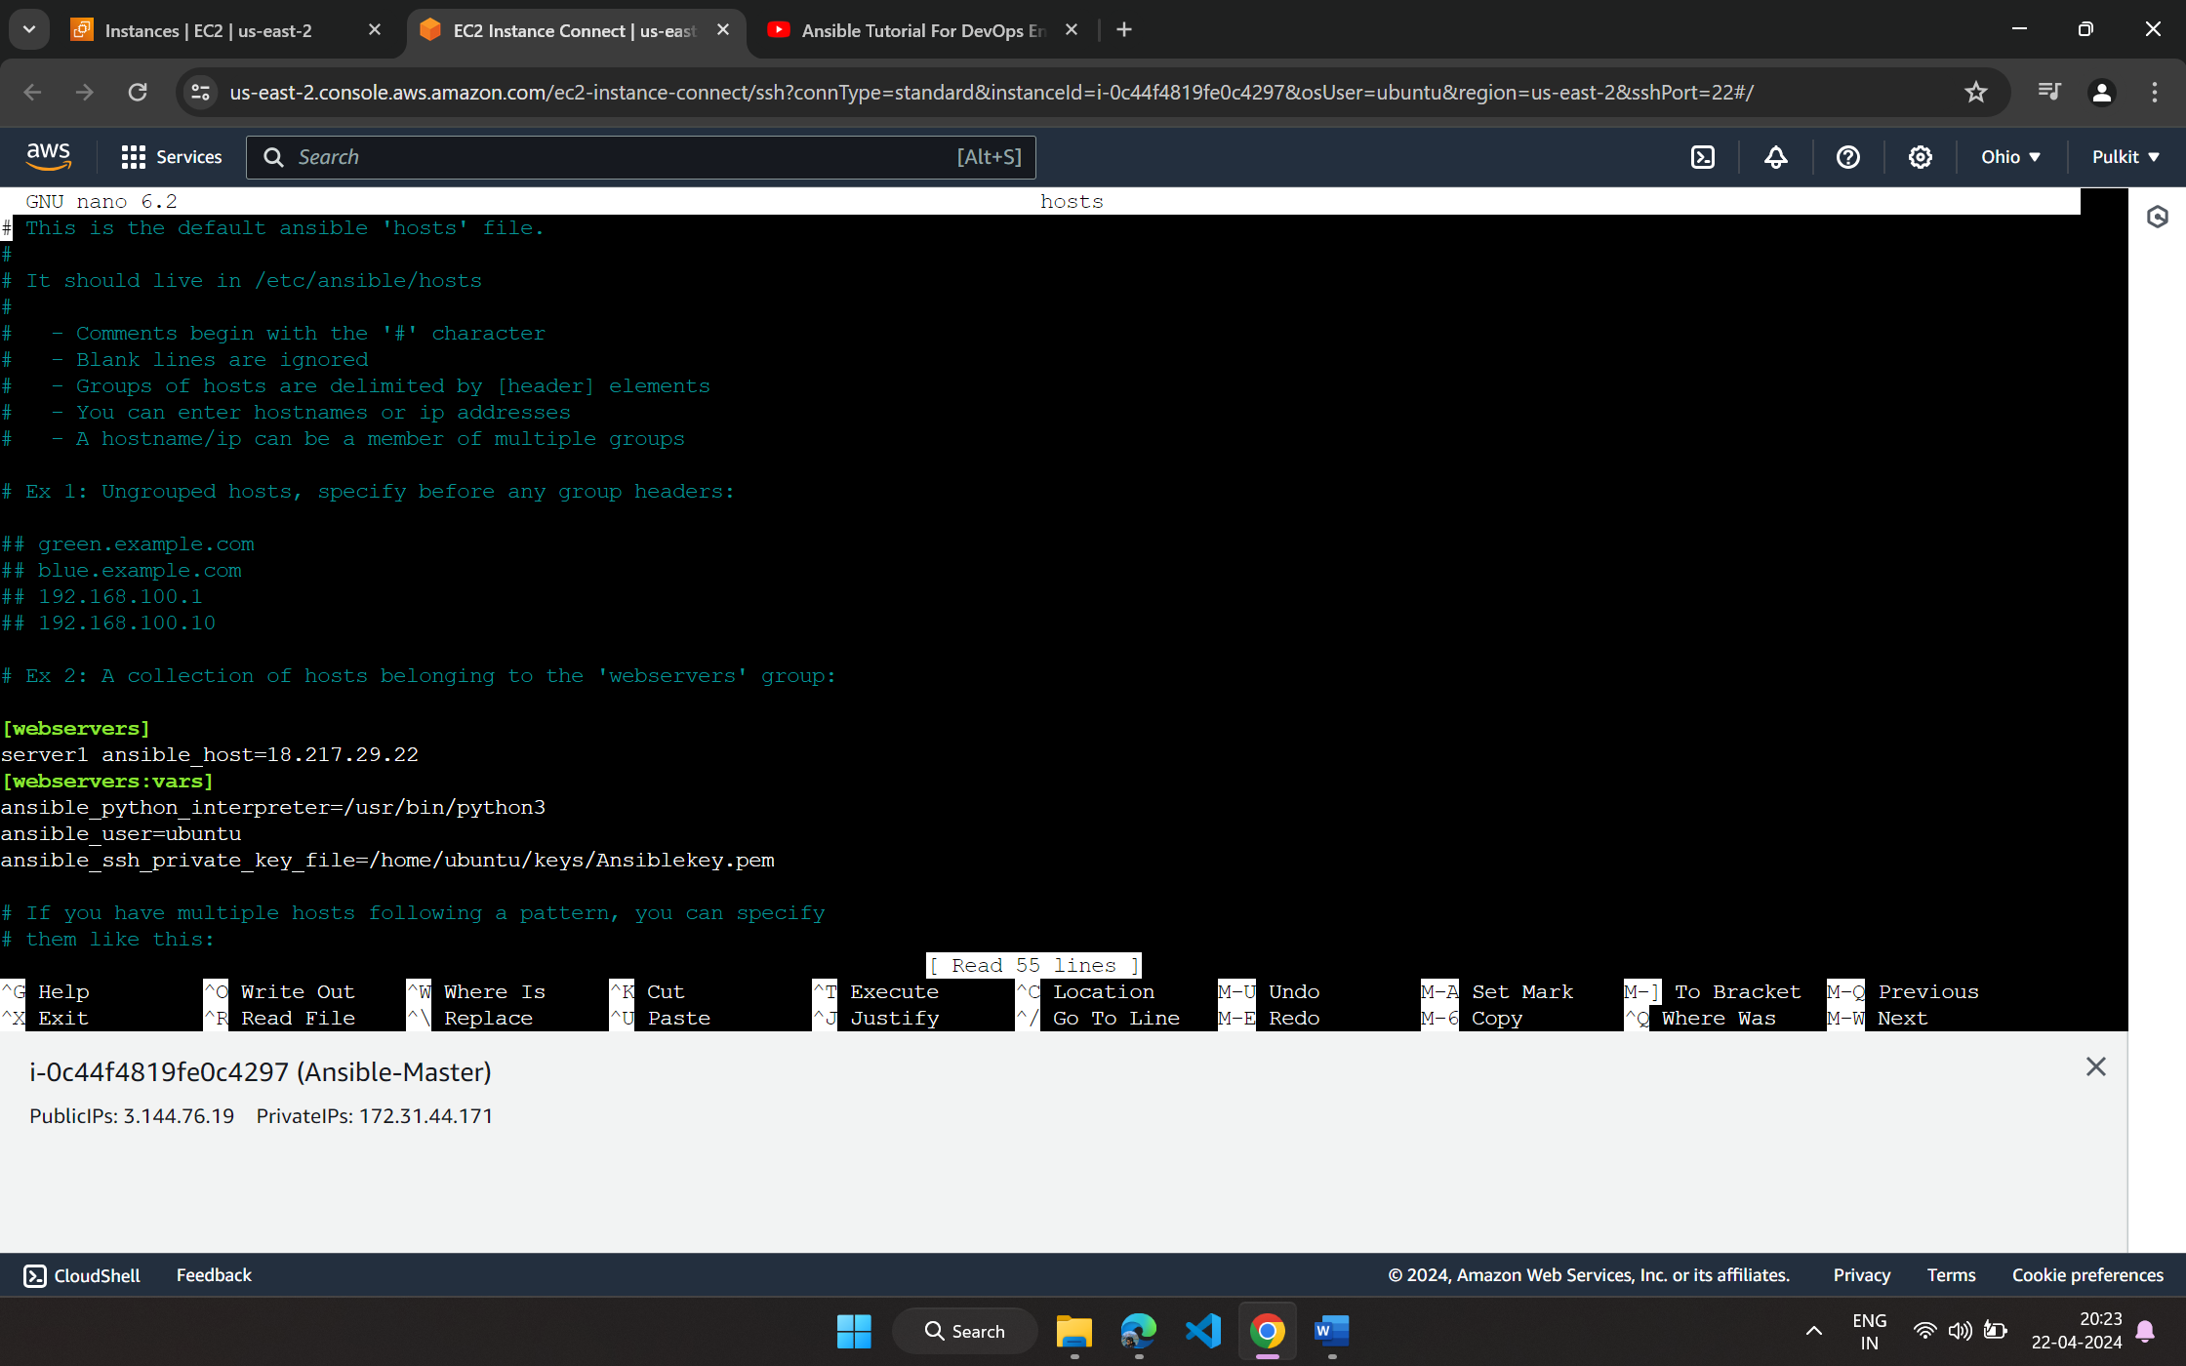

1. Now check connection by **ansible webservers -m ping**

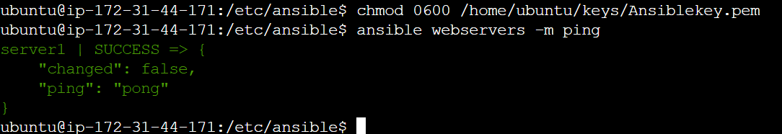

**Experiment-12**

***Ansible Playbook***

1. Create a **nginxplay.yml** file.

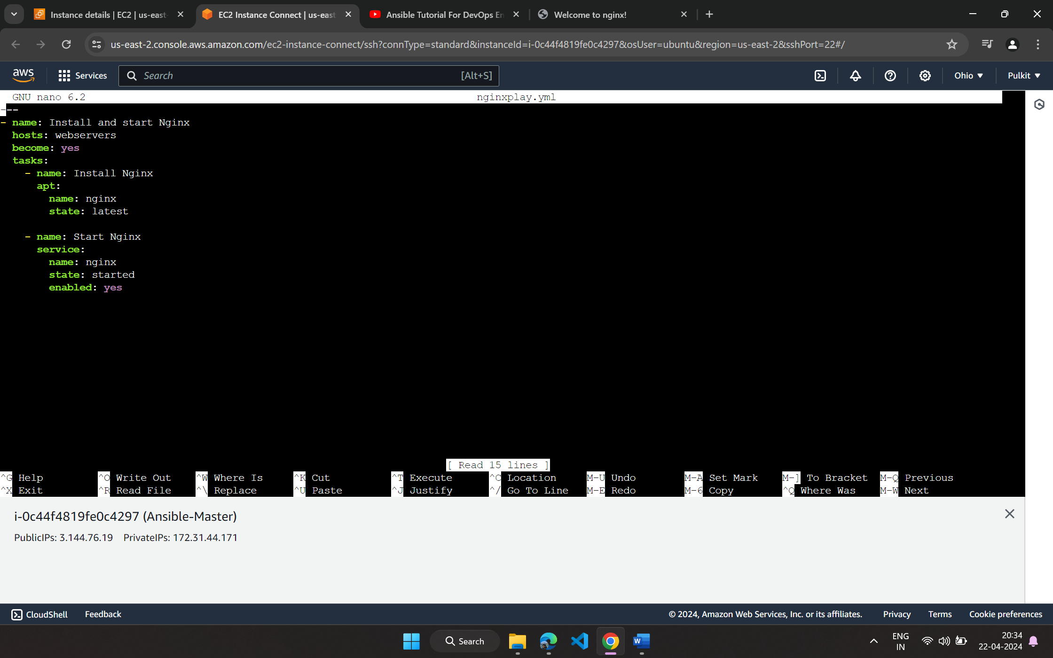

1. Execute this playbook by **ansible-playbook nginxplay.yml**

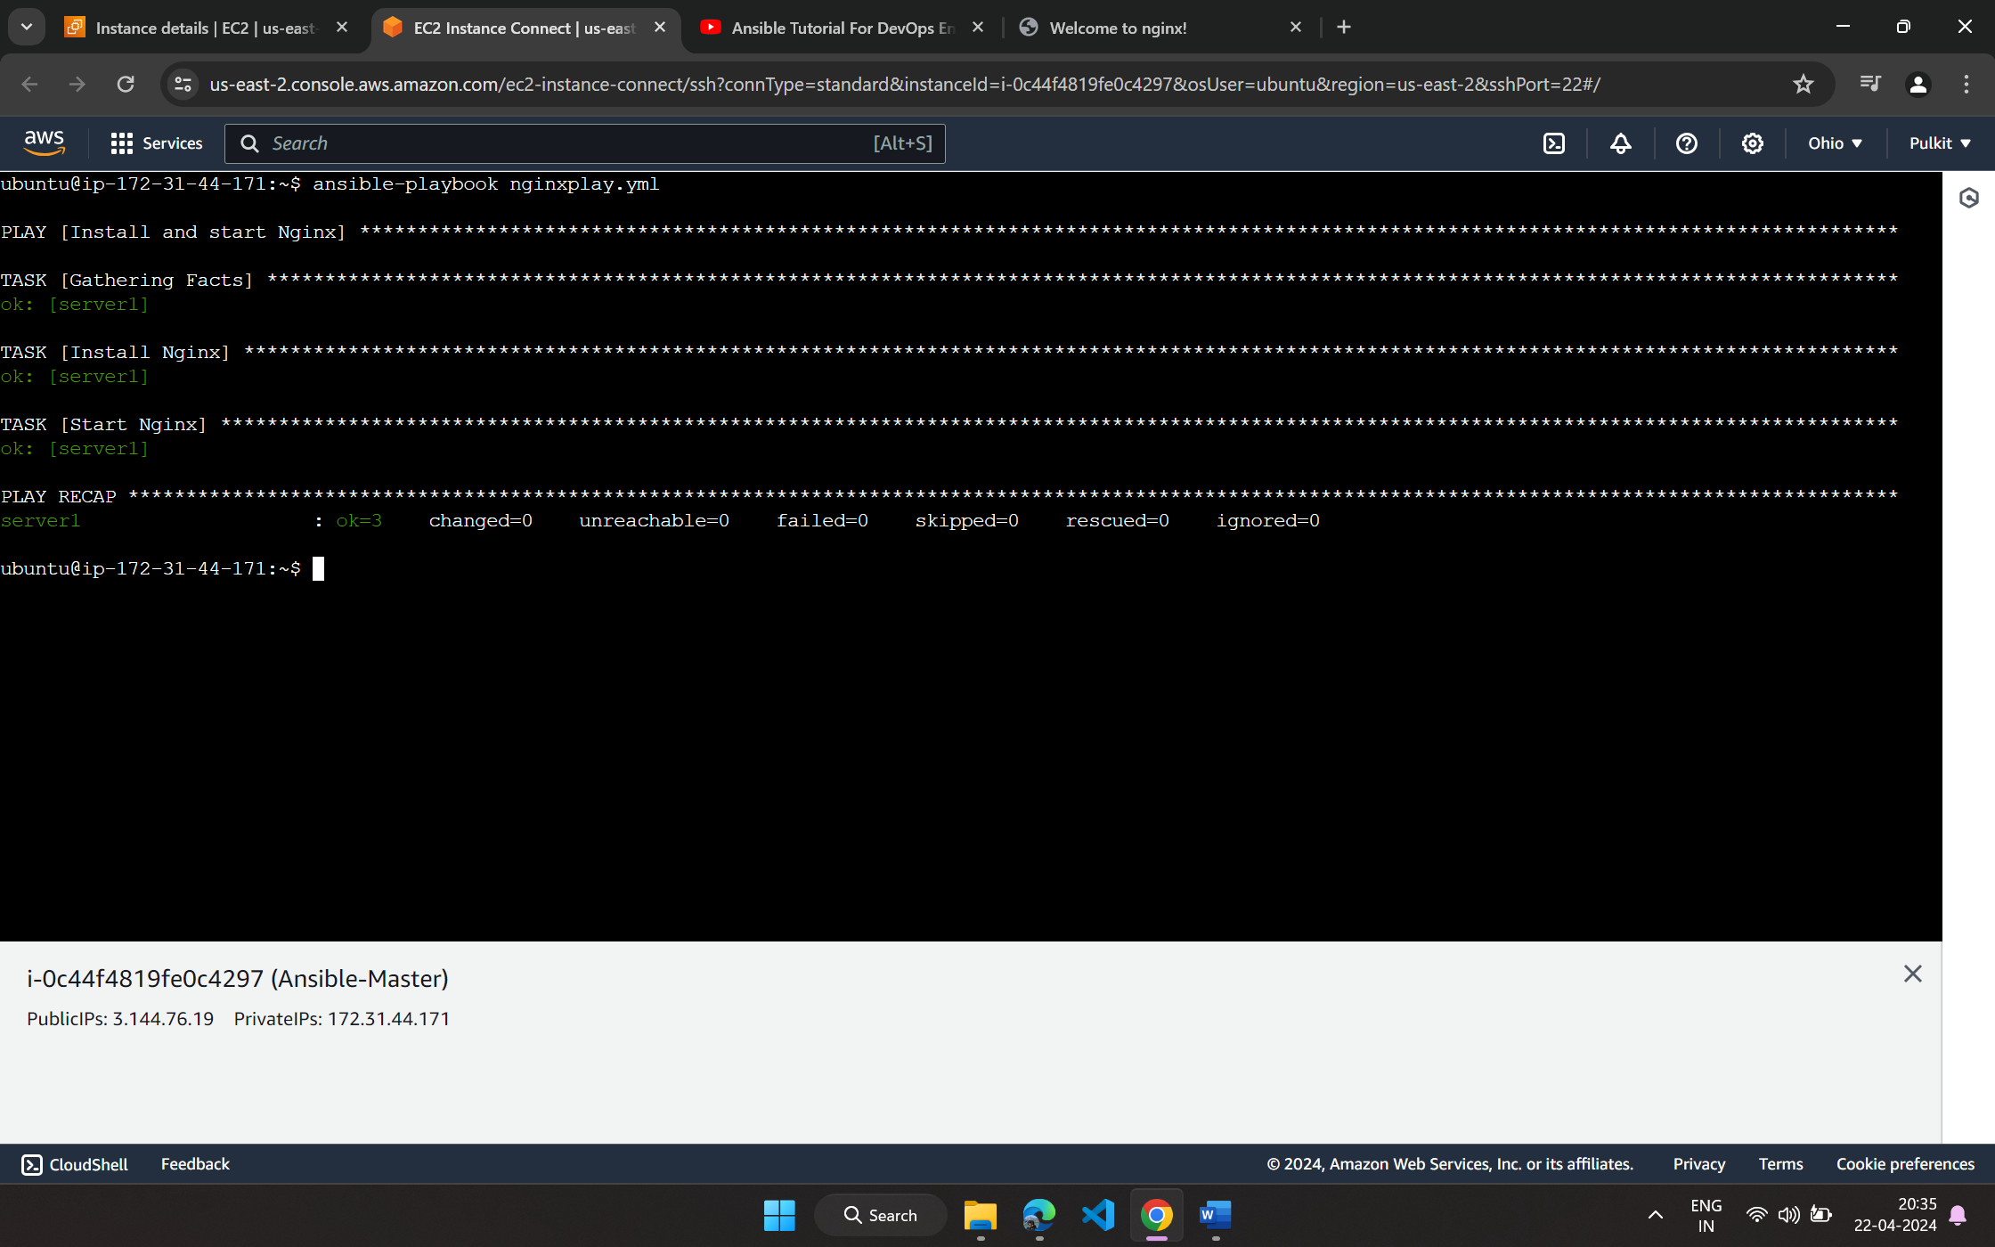

1. To verify open the IP of another server and **Nginx** webpage will be up.

